Workplace Champion Email Templates

Thank you for joining the Starlight Super Steps challenge for 2025!
As we start preparing for the challenge this May, one of the best ways you can help is by getting your colleagues on board, so that together we can bring happiness and fun into the lives of seriously ill children and their families.
Here are some example emails you can shoot across to your workmates to let them know why they should sign up. These are just a guide, so customise them however you like.
Good luck with getting your colleagues on board and let me know if there’s any way I can help!
Meg and the Super Steps team

Email one: Invite your colleagues

Subject: Join Starlight Super Steps and help sick kids!

Hi everyone,

Insert your organisation name is so excited to be joining the Starlight Super Steps challenge this May…and we want you to be part of it!

It’s super easy to get involved – simply walk or run 10,000 steps a day in May (or any distance that works for you) and raise funds to help make hospital a happier place for sick kids!

I’ve decided to take part because… [Add why you’ve personally decided to participate here – adding an element of personal connection will encourage other people to engage, too!]

Join us here: INSERT YOUR ORGANISATION PAGE LINK

Signing up is as easy as 1,2,3:

- Click the link above to visit our team page.
- Click the ‘Join’ button.
- Complete the rego form to create your own fundraising page and you’re ready to go!

Any donations you receive on your page will add to our organisations total.

Not sure about taking part? You can get involved by making a donation to a teammate too.
Click here to search for your colleague by name and support their challenge and help brighten the lives of kids in hospital.

When a child is diagnosed with a serious illness, life can become consumed by hospital and treatment. It’s scary and overwhelming. Every minute of every day, a child is admitted to hospital in Australia.

By doing Super Steps, together we’re helping to bring happiness and fun into the lives of seriously ill children and their families.

So, join us and step up this May!

www.supersteps.org.au

Kind regards,
Your Name

Email two: Reminder to sign up

Subject: There’s still time – step up with us this May!
Hi everyone,
Wanted to give you a quick reminder about the Starlight Super Steps challenge that your organisation name is taking part this year.
We’ve already had lots of people sign up (which is awesome), but there’s still time for you to get involved!
You can choose to walk or run 10,000 steps each day in May (or any distance that works for you), either solo or as part of our organisation name team.
So, ready to do something amazing for sick kids? Join us now!
You can also make a donation to a teammate’s page and help bring happiness and joy to sick kids by heading here.
Kind regards,
Your Name

Email three: Get support

Subject: Will you help us make a difference for sick kids?

Hi everyone,

We’re taking part in Super Steps 2025 to support Starlight Children's Foundation and we’d love your support.
Every minute of every day, a child is admitted to hospital in Australia – kids like Henry.

Hospital has consumed Henry's life since he was diagnosed with Wilms Tumour kidney cancer when Henry was 5 years old. But amidst the fear and pain of cancer treatment, the Starlight team have brightened some of Henry’s toughest days with fun, games and creativity.

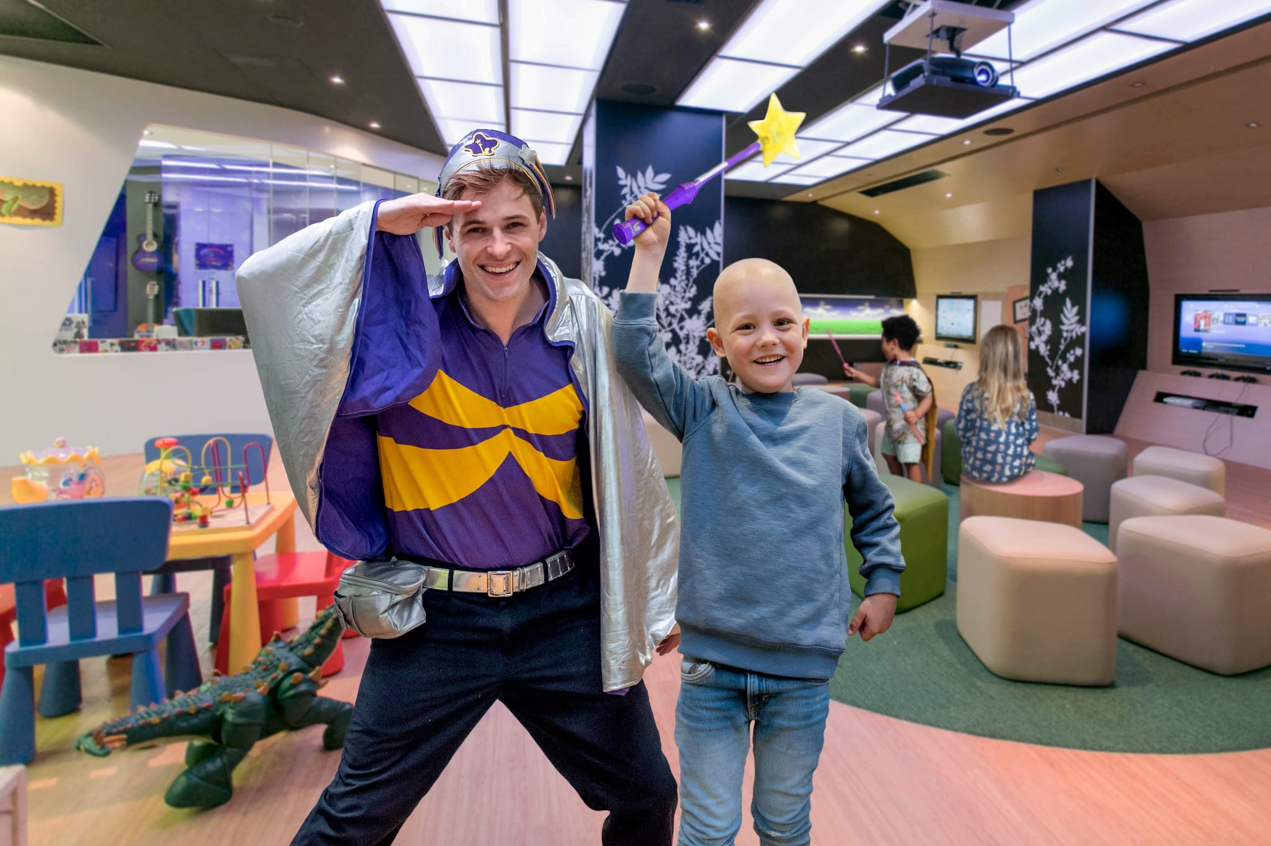

XXX of us are stepping up this May to raise funds to help make hospital a happier place.

Please sponsor and support our efforts to give back and change lives.

Click here to search for your colleague by name and donate to help brighten the lives of kids in hospital.

Thank you so much for your support - it is truly appreciated.

